**Lab No. 12**

**Persisting Data – Shared Preferences**

1. Saving customized key-value pair: Create an app by which user can set and get customized key-value pair. You may follow the GUI given below:

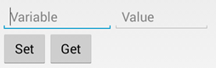

<TextView  
 android:layout_width="wrap_content"  
 android:layout_height="wrap_content"  
 android:fontFamily="serif-monospace"  
 android:text="Lab 12"  
 android:textColor="#000000"  
 android:textSize="36sp"  
 app:layout_constraintBottom_toBottomOf="parent"  
 app:layout_constraintLeft_toLeftOf="parent"  
 app:layout_constraintRight_toRightOf="parent"  
 app:layout_constraintTop_toTopOf="parent" />  
  
<TextView  
 android:layout_width="wrap_content"  
 android:layout_height="wrap_content"  
 android:fontFamily="serif-monospace"  
 android:text="SharedPreference"  
 android:textColor="#000000"  
 android:textSize="36sp"  
 app:layout_constraintBottom_toBottomOf="parent"  
 app:layout_constraintLeft_toLeftOf="parent"  
 app:layout_constraintRight_toRightOf="parent"  
 app:layout_constraintTop_toTopOf="parent" />  
<TextView  
 android:layout_width="wrap_content"  
 android:layout_height="wrap_content"  
 android:fontFamily="serif-monospace"  
 android:text="Question:1"  
 android:textColor="#000000"  
 android:textSize="36sp"  
 app:layout_constraintBottom_toBottomOf="parent"  
 app:layout_constraintLeft_toLeftOf="parent"  
 app:layout_constraintRight_toRightOf="parent"  
 app:layout_constraintTop_toTopOf="parent" />  
  
<LinearLayout  
 android:layout_width="wrap_content"  
 android:layout_height="wrap_content"  
 android:layout_margin="10dp"  
 android:orientation="horizontal"  
 >  
  
 <EditText  
 android:id="@+id/variable"  
 android:layout_width="match_parent"  
 android:layout_height="wrap_content"  
 android:layout_margin="10dp"  
 android:ems="10"  
 android:hint="Variable"  
 android:inputType="textPersonName" />  
  
 <EditText  
 android:id="@+id/value"  
 android:layout_width="match_parent"  
 android:layout_height="wrap_content"  
 android:layout_margin="10dp"  
 android:ems="10"  
 android:hint="Key"  
 android:inputType="number" />  
  
</LinearLayout>

public class MainActivity extends AppCompatActivity {  
private EditText var,key,comment;  
private Button set,get,send;  
private TextView txt;  
 @Override  
 protected void onCreate(Bundle savedInstanceState) {  
 super.onCreate(savedInstanceState);  
 setContentView(R.layout.*activity_main*);  
 var=findViewById(R.id.*variable*);  
 key=findViewById(R.id.*value*);  
 set=findViewById(R.id.*set*);  
 get=findViewById(R.id.*get*);  
 send=findViewById(R.id.*send*);  
 comment=findViewById(R.id.*editTextTextPersonName2*);  
 txt=findViewById(R.id.*textView2*);  
 txt.setText("Bad App\nBest App\n Ver Responsive");  
 set.setOnClickListener(new View.OnClickListener() {  
 @Override  
 public void onClick(View view) {  
 SharedPreferences sharedPreferences = getSharedPreferences("MySharedPref", *MODE_PRIVATE*);  
 SharedPreferences.Editor myEdit = sharedPreferences.edit();  
 // write all the data entered by the user in SharedPreference and apply  
 myEdit.putString("var_", var.getText().toString());  
 myEdit.putInt("key_", Integer.*parseInt*(key.getText().toString()));  
 myEdit.apply();  
 Toast.*makeText*(getApplicationContext(),"Data_Set",Toast.*LENGTH_SHORT*).show();  
 }  
 });  
 get.setOnClickListener(new View.OnClickListener() {  
 @Override  
 public void onClick(View view) {  
 SharedPreferences sh = getSharedPreferences("MySharedPref", *MODE_PRIVATE*);  
 String s1 = sh.getString("var_", "");  
 int a = sh.getInt("key_", 0);  
 var.setText(s1);  
 /* key.setText(a);*/  
 Toast.*makeText*(getApplicationContext(),"Data Get",Toast.*LENGTH_SHORT*).show();  
 }

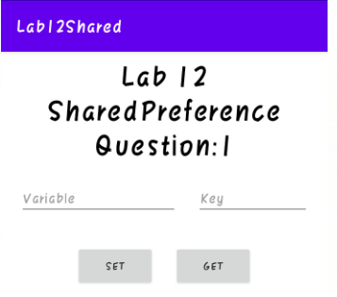

1. Create an app which can save user comments recorder by using SharedPreferences. User must be able to see previous comments chronologically.

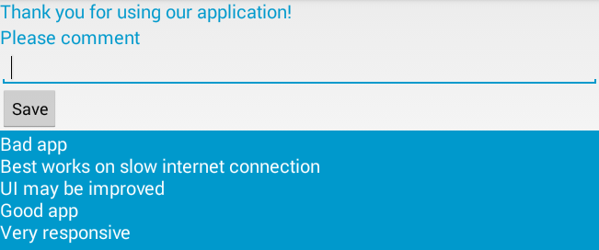

<?xml version="1.0" encoding="utf-8"?>  
<LinearLayout xmlns:android="http://schemas.android.com/apk/res/android"  
 xmlns:app="http://schemas.android.com/apk/res-auto"  
 xmlns:tools="http://schemas.android.com/tools"  
 android:layout_width="match_parent"  
 android:layout_height="match_parent"  
 android:background="#FFFFFF"  
 android:gravity="center"  
 android:orientation="vertical"  
 tools:context=".MainActivity">

<LinearLayout  
 android:layout_width="wrap_content"  
 android:layout_height="wrap_content"  
 android:orientation="horizontal">  
 android:layout_margin="10dp"  
  
 <Button  
 android:id="@+id/set"  
 android:layout_width="match_parent"  
 android:layout_height="wrap_content"  
 android:layout_margin="10dp"  
 android:text="Set" />  
  
 <Button  
 android:id="@+id/get"  
 android:layout_width="match_parent"  
 android:layout_height="wrap_content"  
 android:layout_margin="10dp"  
 android:text="Get" />  
 </LinearLayout>  
  
 <LinearLayout  
 android:layout_width="wrap_content"  
 android:layout_height="wrap_content"  
 android:layout_marginTop="10dp"  
 android:gravity="center"  
 android:orientation="vertical">  
  
 <TextView  
 android:layout_width="wrap_content"  
 android:layout_height="wrap_content"  
 android:fontFamily="serif-monospace"  
 android:text="Question:2"  
 android:textColor="#000000"  
 android:textSize="36sp"  
 app:layout_constraintBottom_toBottomOf="parent"  
 app:layout_constraintLeft_toLeftOf="parent"  
 app:layout_constraintRight_toRightOf="parent"  
 app:layout_constraintTop_toTopOf="parent" />  
  
 <TextView  
 android:layout_width="wrap_content"  
 android:layout_height="wrap_content"  
 android:fontFamily="serif-monospace"  
 android:text="Please Comment"  
 android:textColor="#000000"  
 android:textSize="36sp"  
 app:layout_constraintBottom_toBottomOf="parent"  
 app:layout_constraintLeft_toLeftOf="parent"  
 app:layout_constraintRight_toRightOf="parent"  
 app:layout_constraintTop_toTopOf="parent" />  
  
 <EditText  
 android:id="@+id/editTextTextPersonName2"  
 android:layout_width="match_parent"  
 android:layout_height="wrap_content"  
 android:layout_marginTop="10dp"  
 android:ems="10"  
 android:hint="Comment Here!!"  
 android:inputType="textPersonName"  
 />  
 <Button  
 android:id="@+id/send"  
 android:layout_width="match_parent"  
 android:layout_height="wrap_content"  
 android:text="Send" />  
 <TextView  
 android:id="@+id/textView2"  
 android:layout_width="match_parent"  
 android:layout_height="match_parent"  
 android:layout_marginTop="10dp"  
 android:height="200dp"  
 android:background="#00897B"  
 android:fontFamily="sans-serif-black"  
 android:textColor="#FFFFFF"  
 android:textSize="24sp" />  
 </LinearLayout>  
</LinearLayout>

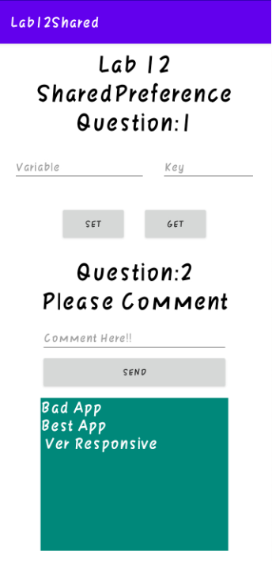send.setOnClickListener(new View.OnClickListener() {  
 @Override  
 public void onClick(View view) {  
 Toast.*makeText*(getApplicationContext(),"Please Enter Comment",Toast.*LENGTH_SHORT*).show();  
 if (comment.getText().toString().equals(""))  
 {  
 Toast.*makeText*(getApplicationContext(),"Please Enter Comment",Toast.*LENGTH_SHORT*).show();  
 }  
 else  
 {  
 SharedPreferences sharedPreferences = getSharedPreferences("Comment", *MODE_PRIVATE*);  
 SharedPreferences.Editor myEdit = sharedPreferences.edit();  
 // write all the data entered by the user in SharedPreference and apply  
 myEdit.putString("com", comment.getText().toString());  
 myEdit.apply();  
 Toast.*makeText*(getApplicationContext(),"Data Set",Toast.*LENGTH_SHORT*).show();  
 SharedPreferences sh = getSharedPreferences("Comment", *MODE_PRIVATE*);  
 String s1 = sh.getString("com", "");  
 txt.append(s1);  
  
 }});

